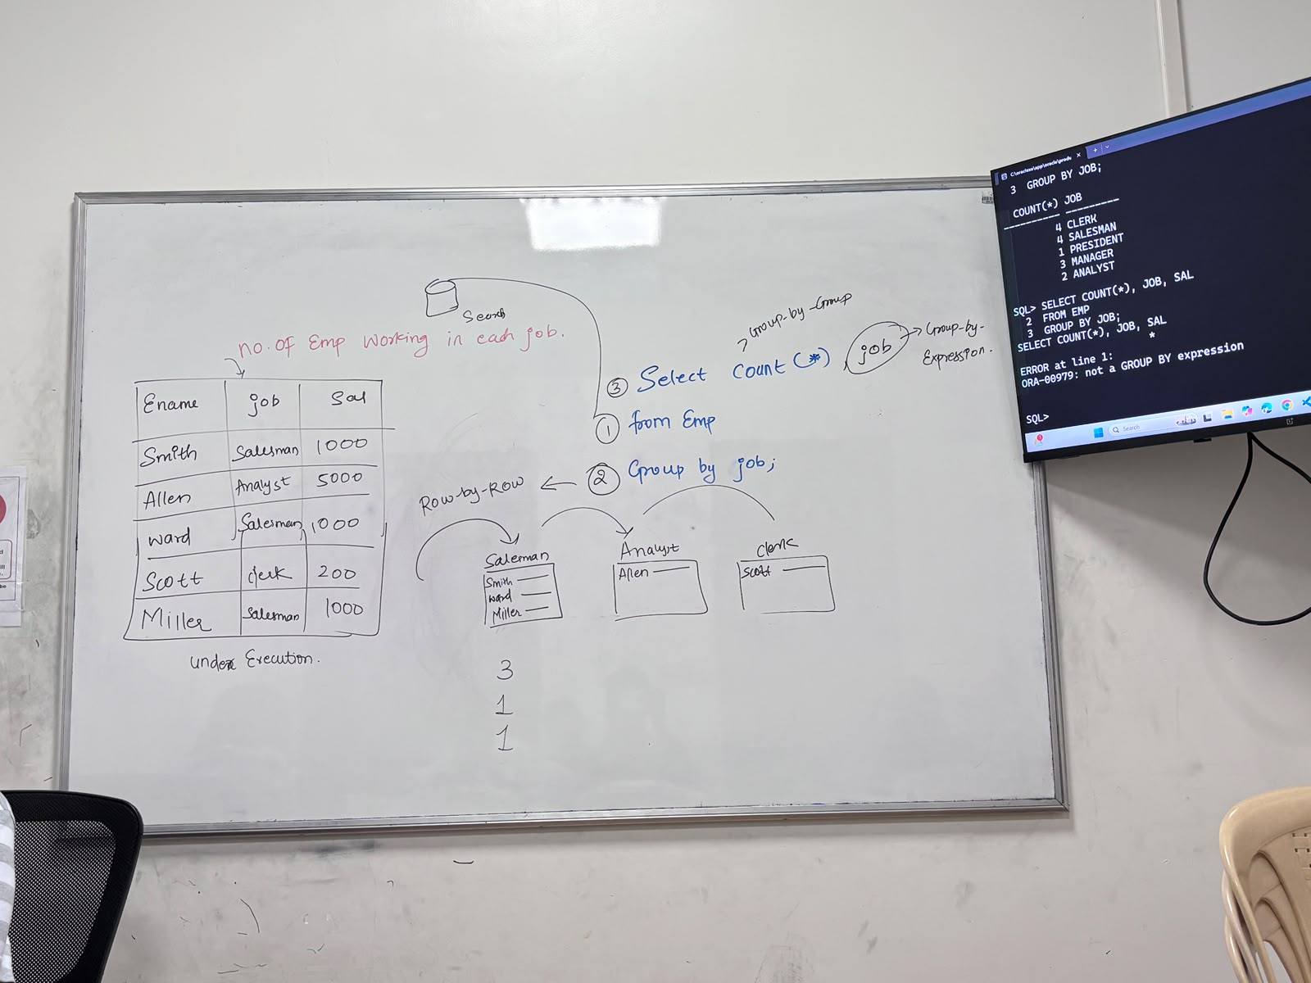
GROUP BY CLAUSE
It is used to create a group of records
SYNTAX: SELECT GROUP_FUCTION/GROUP_BY_EXPRESSION
FROM TABLE_NAME
[WHERE <FILTER_CONDITION>]
GROUP BY COLUMN_NAME/EXPRESSION;

ORDER OF EXECUTION:
- FROM
- WHERE (IF PRESENT)
- GROUP BY……..ROW-BY-ROW
- SELECT ----------GROUP-BY-GROUP

CHARACTERISTICS OF GROUP BY CLAUSE:
- GROUP BY CLAUSE EXECUTES ROW-BY-ROW
- AFTER EXECUTING THE GROUP BY CLAUSE, WE GET GROUPS
- IT WILL GET EXECUTED AFTER THE WHERE CLAUSE IF PRESENT, OTHERWISE
EXECUTES AFTER EXECUTION OF FROM CLAUSE
- GROUP BY CLAUSE CAN BE USED WITHOUT WHERE CLAUSE ALSO.
- ANY CLAUSE WHICH IS EXECUTED AFTER EXECUTION OF GROUP BY CLAUSE
IT WILL EXECUTE GROUP BY GROUP
- THE COLUMN NAME OR EXPRESSION USED IN GROUP BY CLAUSE AS WELL AS IN SELECT CLAUSE IS KNOWN AS GROUP BY EXPRESSION.

HAVING CLAUSE

IT IS USED TO FILTER THE GROUPS

SYNTAX: SELECTC GROUP _FUCTION/GROUP BY GROUP EXPRESSION
FROM TABLE_NAME
[WHERE <FILTER_CONDITION>]
GROUP BY COLUMN_NAME/EXPRESSION
HAVING <GROUP_FILTER_CONDITION>

ORDER OF EXECUTION
- FROM
- WHERE (IF PRESENT)----ROW-BY-ROW
- GROUP BY-----ROW BY ROW
- HAVING --- GROUP-BY-GROUP
- SELECT – GROUP BY GROUP

NOTES:
- HAVING CLAUSE EXECUTES GROUP-BY-GROUP
- HAVING CLAUSE WILL EXECUTE AFTER THE EXECUTION OF THE GROUP BY CLAUSE
- IN HAVING CLAUSE, WE WILL PASS GROUP FILTER CONDITION, WHICH WILL
FILTER THE GROUP CREATED BY THE GROUP BY CLAUSE BASED ON THE GIVEN CONDITION
- IN HAVING CLAUSE, WE CAN USE MRF.

WHERE CLAUSE | HAVING CLAUSE
- WHERE CLAUSE EXECUTES ROW-BY-ROW | 1.HAVING CLAUSE GROUP BY GROUP
- WHERE CLAUSE EXECUTES AFTER THE EXECUTION OF FROM CLAUSE | 2.HAVING CLAUSE EXECUTES AFTER THE EXECUTION OF GROUP BY CLAUSE
- WHERE CLAUSE IS USED TO FILTER THE CONDITIONS | 3.HAVING CLAUSE IS USED TO FILTER THE GROUP
- WE CANNOT WRITE MRF FUNCTIONS IN WHERE CLAUSE | 4.GROUP BY CLAUSE IS MANDATORY
- GROUP BY CLAUSE IS NOT MANDATORY | 5.WE CAN WRITE MRF IN HAVING CLAUSE

GROUP

- WAQTD NO OF EMPLOYEES WORKING IN EACH JOB
SELECT COUNT(*)
FROM EMP
GROUP BY JOB;
- WAQTD NO OF EMPLOYEE WORKING IN EACH DEPARTMENT
SELECT COUNT(*)
FROM EMP
GROUP BY DEPTNO;
- WAQTD NUMBER OF EMPLOYEES WORKING IN EACH DEPT EXCEPT THE EMPLOYEE WORKING AS ANALYST
SELECT COUNT(*)
FROM EMP
WHERE JOB NOT IN (‘ANALYST’)
GROUP BY DEPTNO;
- WAQTD MAXIMUM SALARY GIVEN TO EACH JOB
SELECT COUNT(*), MAX(SAL) FROM EMP GROUP BY JOB;

- WAQTD NUMBER OF EMPLOYEES WORKING IN EACH JOB IF THE EMPLOYEE HAVE CHARACTER ‘A’ IN THEIR NAMES
SELECT COUNT(*) FROM EMP WHERE ENAME LIKE '%A%' GROUP BY JOB;
- WAQTD NUMBER OF EMPLOYEES GETTING COMMISSION IN EACH DEPT
SELECT COUNT(*) FROM EMP WHERE COMM IS NOT NULL GROUP BY DEPTNO;
- WAQTD TO FIND NUMBER OF EMPLOYEE WORKING IN EACH DEPT IF THERE ARE LEAST 3 EMPLOYEE IN EACH DEPT
SELECT COUNT(*) FROM EMP GROUP BY DEPTNO HAVING DEPTNO>3;
- WAQTD THE DESIGNATION IN WHICH THERE ARE AT LEAST 2 EMPLOYEES PRESENT.
SELECT COUNT(*) FROM EMP GROUP BY JOB HAVING COUNT(*) > 2;
- WAQTD SALARY THAT ARE REPETED EXACTALY TWICE
SELECT COUNT()
- WAQTD THE SALARY THAT IS REPEATED
- WAQTD NUMBER OF EMPLOYEES WORKING IN EACH DEPT HAVINFG AT LEAST 2 EMPLOYEES CHARACTER ‘A’ OR ‘S’ IN THEIR NAMES
- WAQTD JOB AND TOTAL SALARY OF EACH JOB, IF THE TOTAL SALARY OF EACH JOB IS GRATER THAM 3450
- WAQTD JOB AND TOTAL SALARY OF THE EMPLOYEES IF THE EMPLOYEES ARE EARNING MORE THAN 1500
- WAQTD JOB WISE MAXIMUM SALARY IF THE MAXIMUM SALARY OF EACH JOB EXCEEDS 2000.
- WAQTD NUMBER OF EMP EARNING SAL MORE THAN 1200 IN EACH JOB AND THE TOTAL SAL NEEDED TO PLAY EMP OF EACH JOB MUST EXCEEDS 3800.

